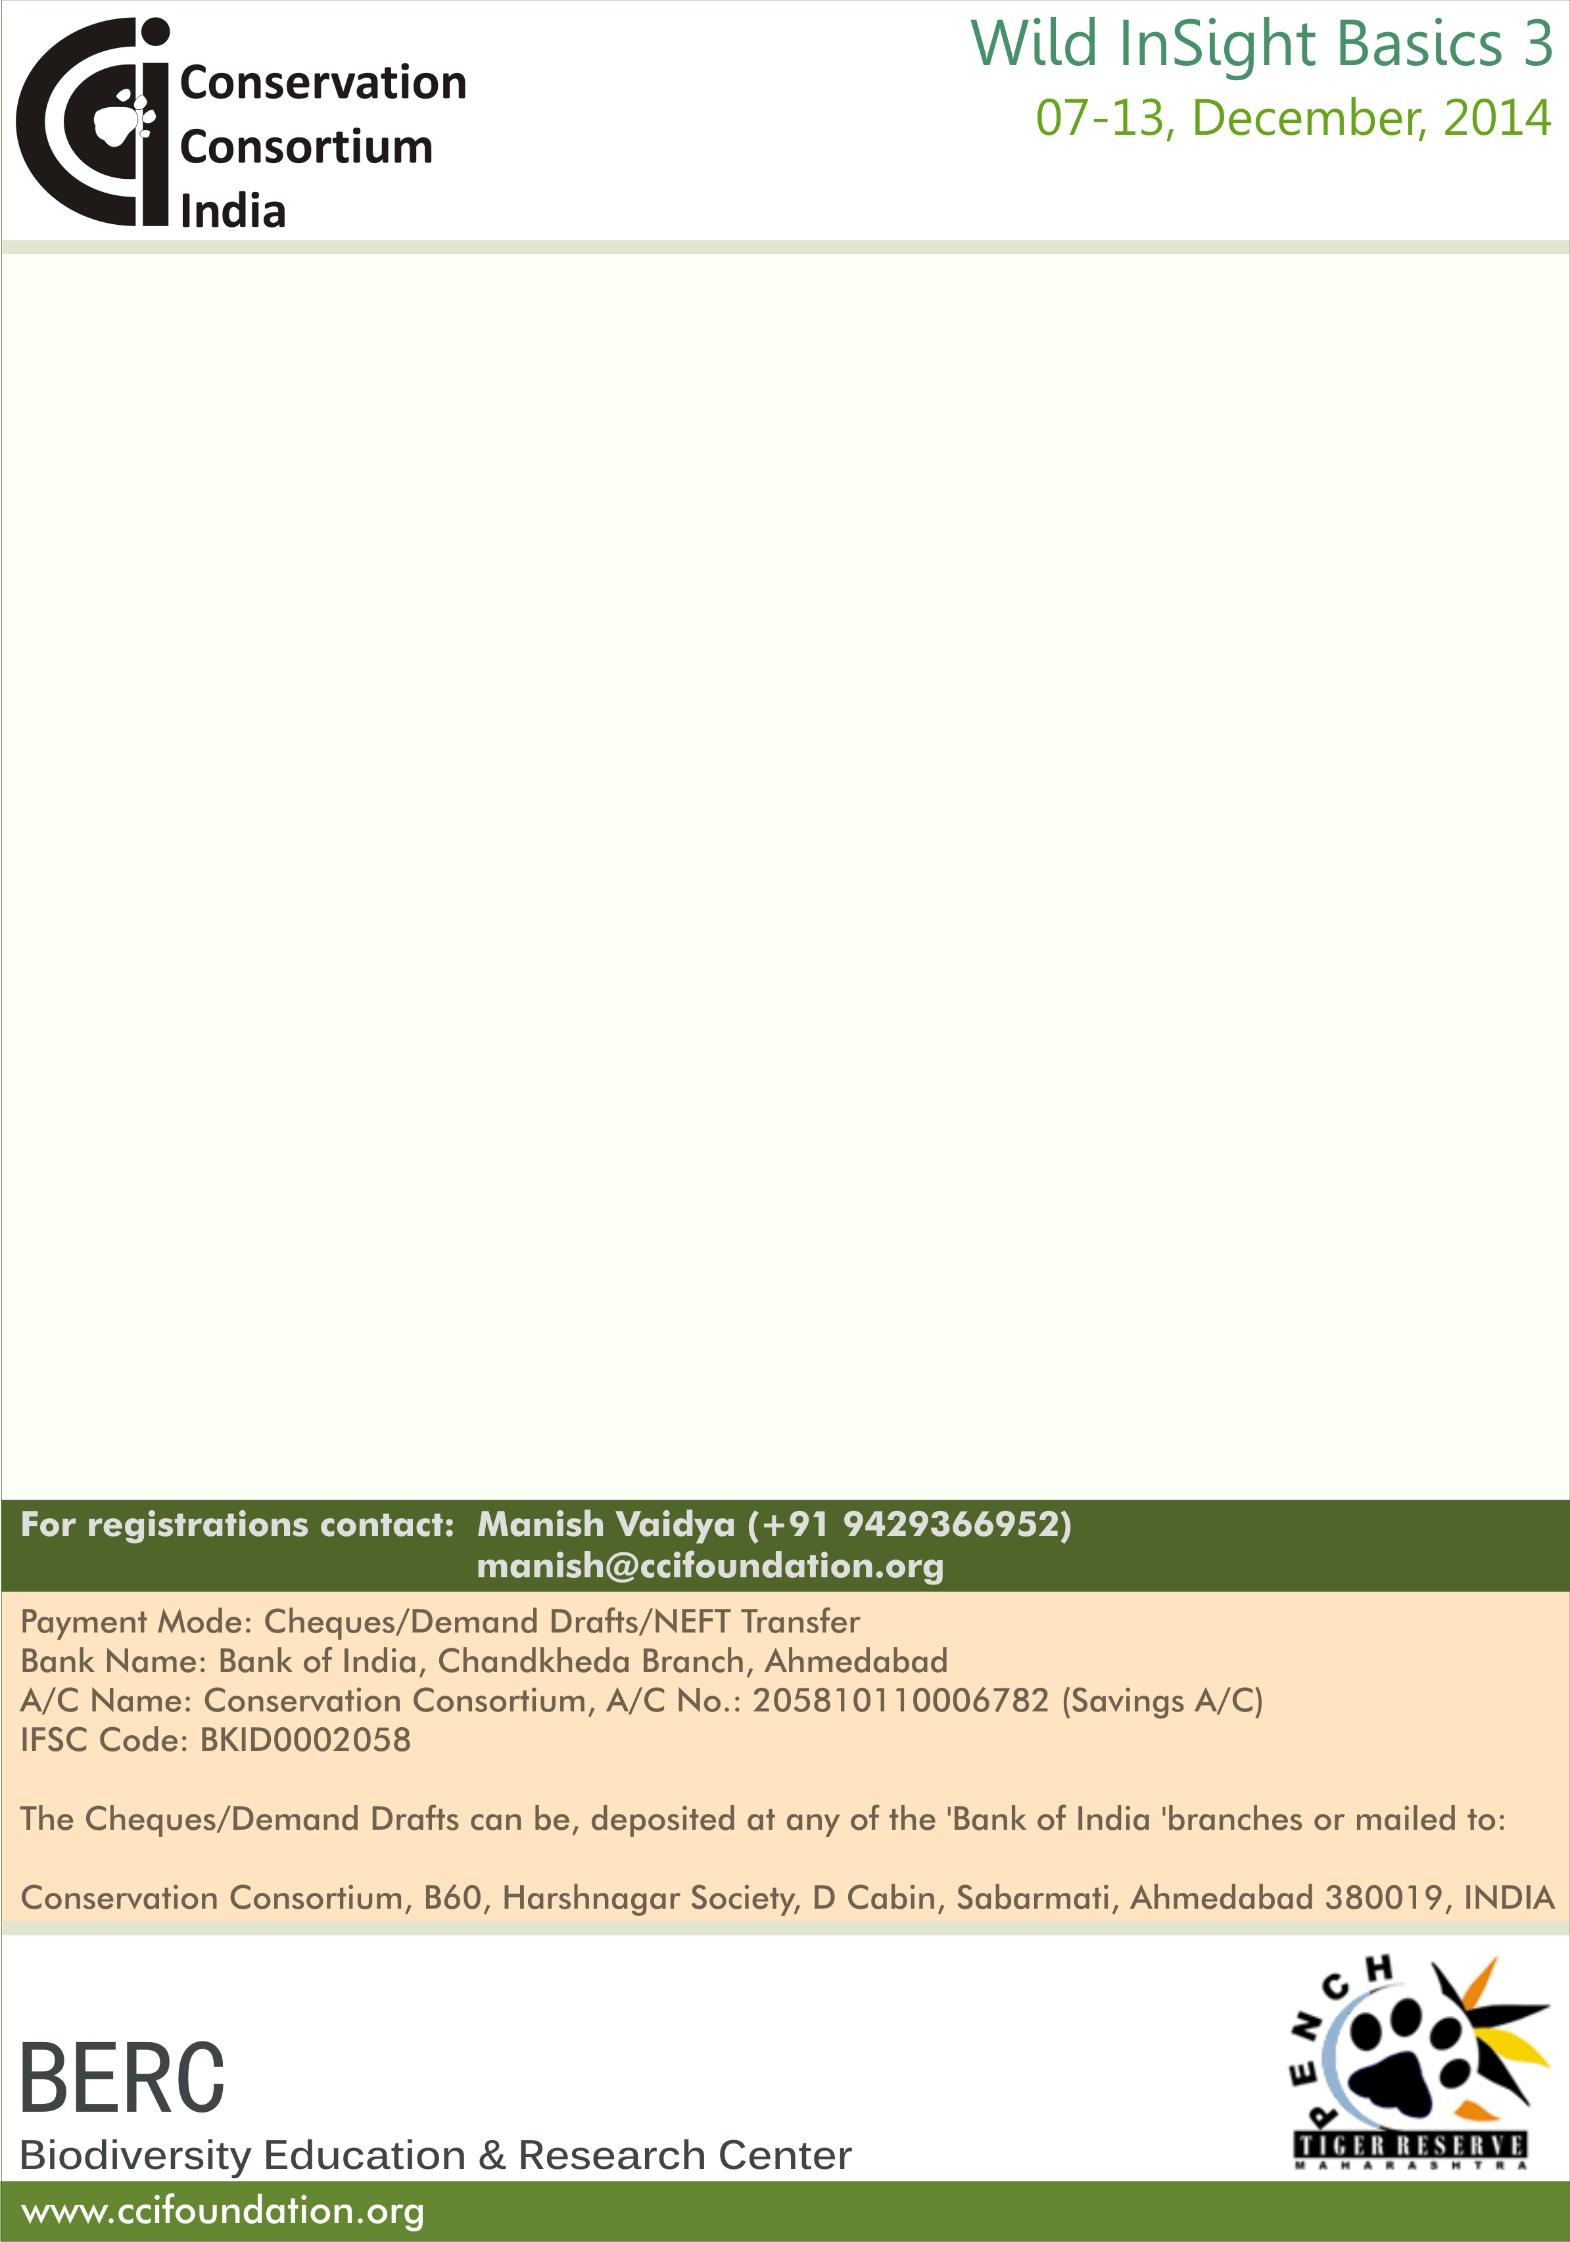
Participant Registration Form

Name:

Contact Address:

City:
Pincode:
State:

Contact Number: Email:
Emergency Contact Number: Name of the contact:
Relation with the contact:

Date of Birth:
Blood Group:

Medical Problems (if any):

Highest Academic Qualification:
(Intermediate, Graduate, Post Graduate, Professional Degree, Other)
In case of ‘Other’ please specify the degree/certificate:

Current Occupation:
Hobbies/Interests:

Interest in Nature/Wildlife/Conservation:
(Please write briefly on what you expect from the programme)

Please post a scanned copy of your recent passport size photograph here.

